Page Setup
Margins: 2 cm for top, bottom, left and right; page orientation: portrait; paper size: A4; grid style: defined line and character grid; 44 characters per line, 44 lines per page.
Paragraph Settings
0 line spacing before and after paragraphs; single line spacing.
All English letters and numerals in the text shall adopt Times New Roman.
Format Specifications
Title: No.2 Bold Hei
Leave one line of No.5 font space (about 0.7 cm)
XX,XX,XX（No.4 Fangsong）
Author Affiliation (secondary unit), Province (Municipality), City (County), Postal Code (Small No.5 Kai)
Example: School of Transportation and Civil Engineering, Shandong Jiaotong University, Jinan 250357, China
Leave one line of No.5 font space
Abstract (Small No.5 Bold Hei): .................. (Small No.5 Song)
Keywords (Small No.5 Bold Hei): XXX; XXX; XXX (Small No.5 Song)
Chinese Library Classification No.: (Small No.5 Bold Hei) Document Code: A Article ID: 1672-0032(2026)0X-00XX-0X
Leave one line of No.5 font space
Text Hierarchy
0 Introduction (No.4 Bold Hei)
Leave one line of No.5 font space
Body text content
X X X X X X X X X X X X X X X X X X X X X X X X X X X X X X X X X X X X X X X X X X X X X X X X X X X X X X X X X X X X. (No.5 Song)
1 XXXXXX (No.4 Bold Hei)
Body text content
X X X X X X X X X X X X X X X X X X X X X X X X X X X X X X X X X X X X X X X X X X X X X X X X X X X X X X X. (No.5 Song)
1.1 XXXXXX (No.5 Bold Hei)
1.1.1 XXXXXX (No.5 Song)
Body text content
X X X X X X X X X X X X X X X X X X X X X X X X X X X X X X X X X X X X X X X X X X X X X X X X X X X X X X X. (No.5 Song)
1.2 XXXXXX (No.5 Bold Hei)
Body text content
X X X X X X X X X X X X X X X X X X X X X X X X X X X X X X X X X X X X X X X X X X X X X X X X X X X X X X X. (No.5 Song)
Image Layout
Leave 0.5 cm blank space between figures and main text
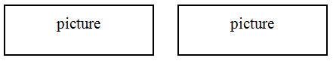
a) XXXXX b) XXXX (Small No.5 Song)
1-XX; 2-XXXX; 3-XXX. (No.6 Song)
Figure Serial Number (Small No.5 Bold Hei) Figure Caption (Small No.5 Kai)
Leave 0.5 cm blank space before and after figures
Table Layout
All texts inside tables: No.6 Song Font
Table 1 XXXXXX (Small No.5 Bold) Unit:

Leave 0.5 cm blank space between tables and main text
References: (No.5 Bold Hei)
[1] ROTH C, KANG S M, BATTY M,et al. A long-time limit for world subway networks[J]. Journal of the Royal Society Interface, 2012, 9(75): 2540-2550.(Small No.5 Kai and Small No.5 Time New Roman)
Leave two lines of No.5 font space

English Version Format
English Title (No.4 Bold Hei / No.3 Bold Hei)
Leave one line of No.5 font space
Authors (No.4 Time New Roman)
Affiliations (Small No.5 Time New Roman)
Leave one line of No.5 font space
English Abstract (No.5 Bold Time New Roman):XXXXXXXXXXXXXXXXXXXXXXXXXXXXXXXX (No.5 Time New Roman)
Keywords (No.5 Bold Time New Roman): XXXXXXXXXXXX(No.5 Time New Roman)
(Responsible Editor: XXX)（Small No.5 Song Font）

Specific Writing Requirements
(1) Abstract: Must cover research purpose, methods, results and conclusions. Writing logic: clarify research problems, adopt targeted research methods, obtain specific results and draw valid conclusions. Content shall be specific rather than sketchy, with a word count of over 300 words.
(2) Introduction: Briefly elaborate the following contents in generally three paragraphs:
a) Research background and research purposes;
b) Domestic and overseas research status, research hotspots and existing deficiencies via reviewing relevant literatures; illustrate similarities and differences compared with previous studies, and highlight innovations and improvements;
c) Core research contents, research significance, main research methods and expected research objectives.
(3) Main Body: Highlight technical innovations and research approaches. Elaborate research characteristics via adopted methods, analyze and discuss research results; avoid writing in the form of construction reports.
(4) Conclusions: Include verified research conclusions, unsolved difficulties, differences and similarities with published studies, as well as theoretical and practical research values.
(5) References: Expand the quantity to about 25 pieces, prioritizing high-quality journal papers published in the latest five years.
Example：
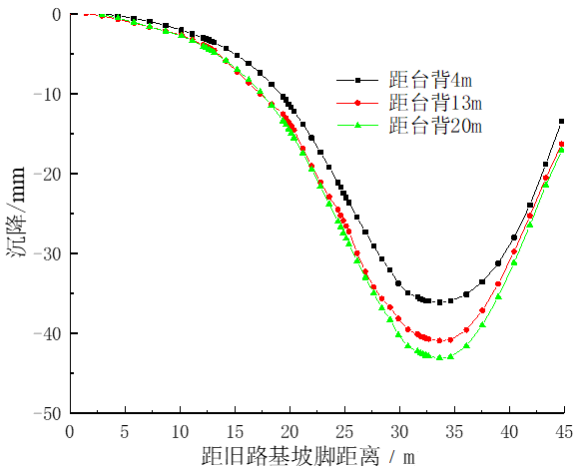
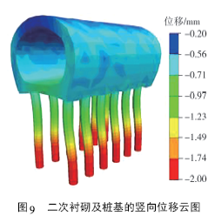
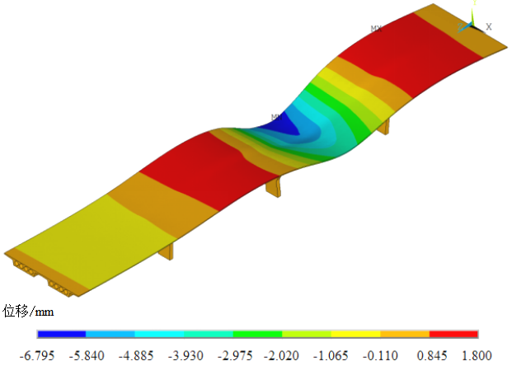
图8 CFRP板加固前竖向位移云图
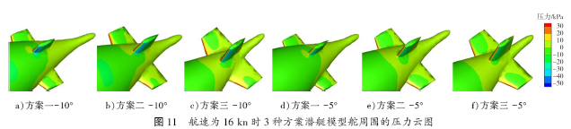

Manuscript Received Date (Small No.5 Bold Hei): 2004-11-20 (Small No.5 Time New Roman)] First Author Introduction (Small No.5 Bold Hei): XXX (1970–), gender, native place, professional title, educational background, main research directions (Small No.5 Kai), E-mail: . Corresponding Author Introduction (Small No.5 Bold): XXX (1970–), gender, native place, professional title, educational background, main research directions (Small No.5 Kai), E-mail: (Times New Roman). ].

